**A - Preparation**

1. Install **Cocos Creator version 2.4.6** from [**https://www.cocos.com/en/creator/download**](https://www.cocos.com/en/creator/download)
2. Download & install DashBoard  
   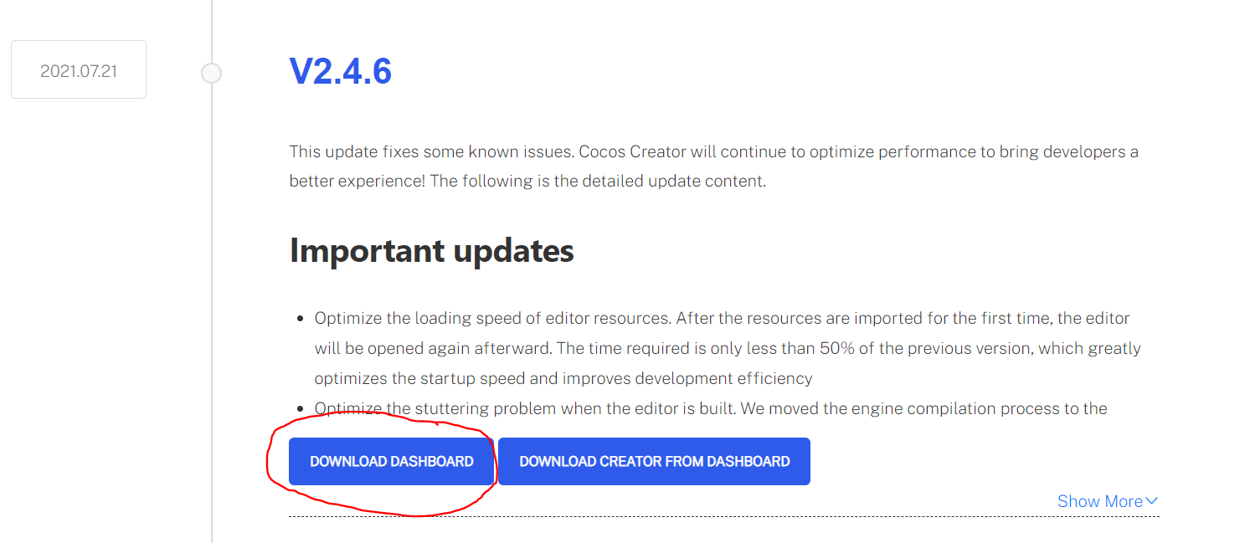
3. From DashBoard, select Editor & Install version **V2.4.6**

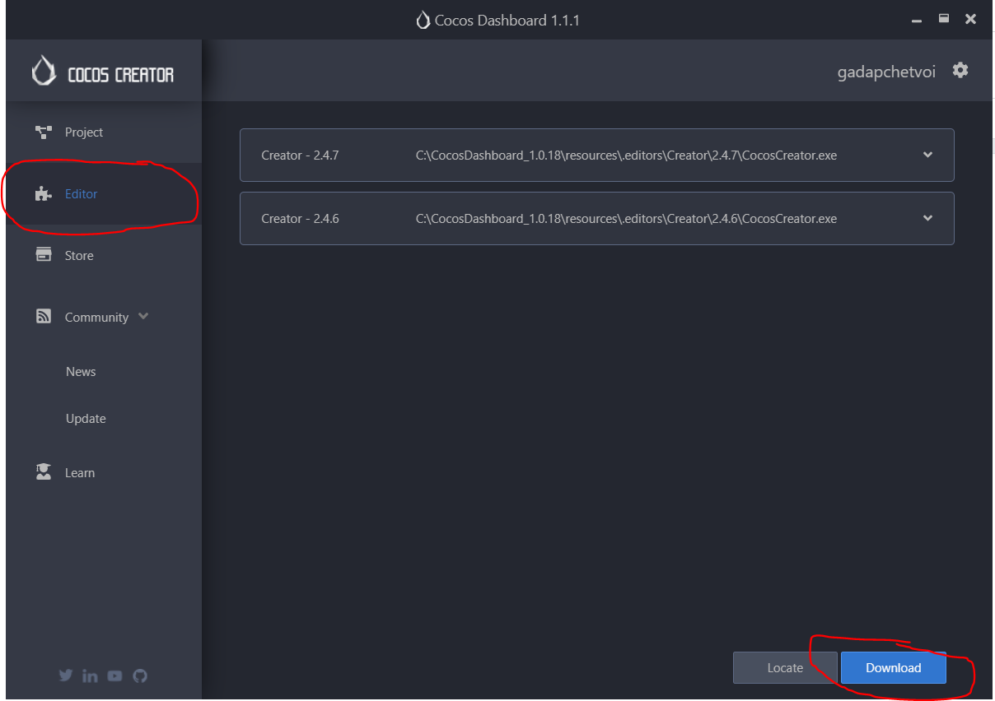

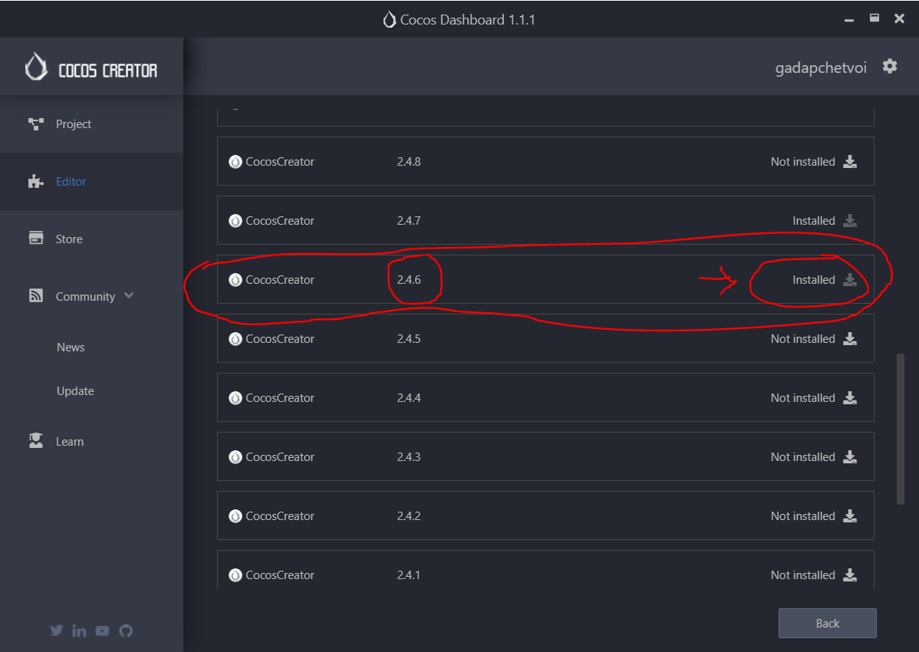

1. Pull the project git to PC into folder **/DeLaODigital_PuzzleKingdom**
2. Prepare the set of core resources to put into the game (manually edit the sample files or auto generated from AdminPanel)
   1. Core data file “**system_data.ts**”
   2. Folder “**/frames**” which contains all the categories & frames with identical names as in “**system_data.ts**”  
        
      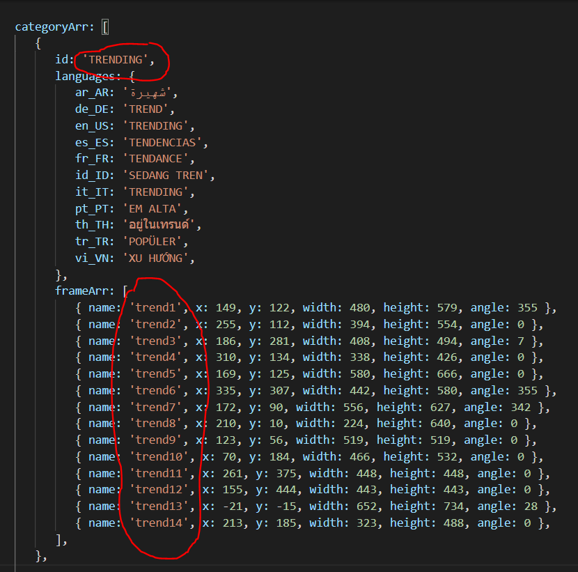

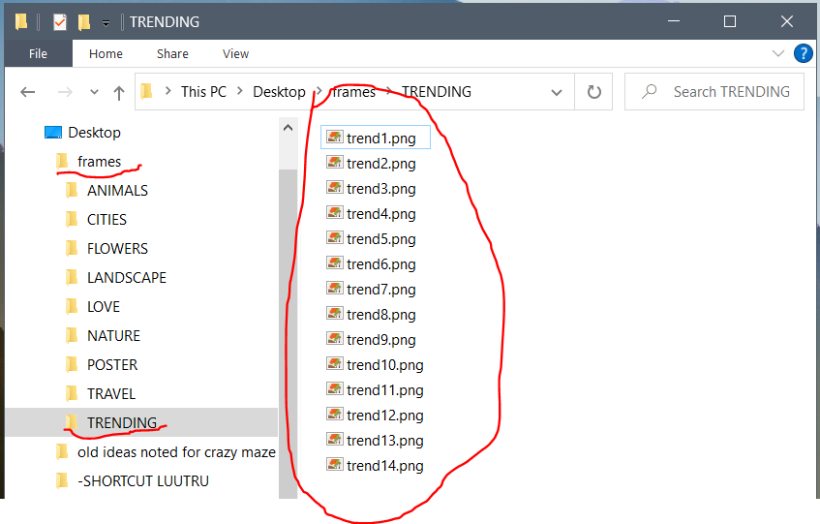

**B - Build the game**

1. Replace old files in project folder with prepared files of core-resources
   1. Delete all files & folders inside the 2 folders

**...\DeLaODigital_PuzzleKingdom\assets\script\system_data**

**...\DeLaODigital_PuzzleKingdom\assets\resources\frames**

* 1. Copy the prepared file “**system_data.ts**” into the folder   
       
      **...\DeLaODigital_PuzzleKingdom\assets\script\system_data**
  2. Copy all sub-folders inside the prepared folder “**/frames**” into the folder

**...\DeLaODigital_PuzzleKingdom\assets\resources\frames**

1. Open the project with Cocos Creator & build

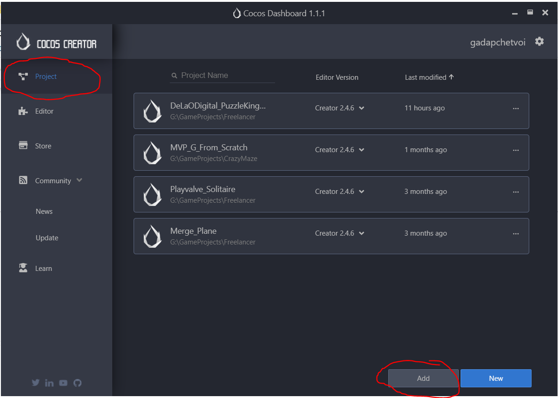

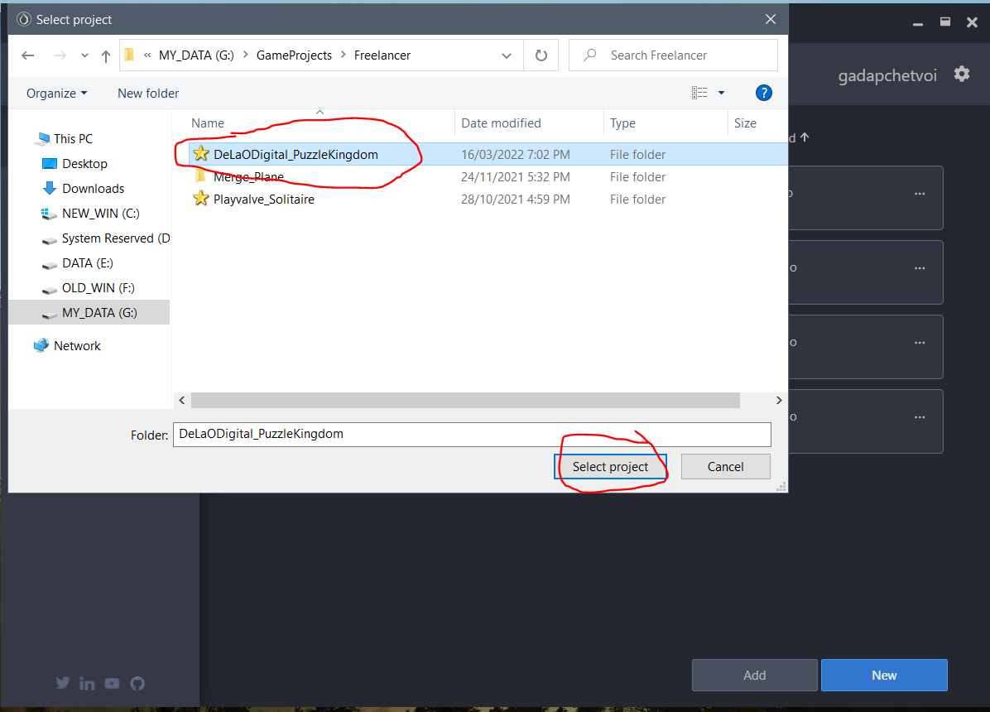

=> Click project in list to open

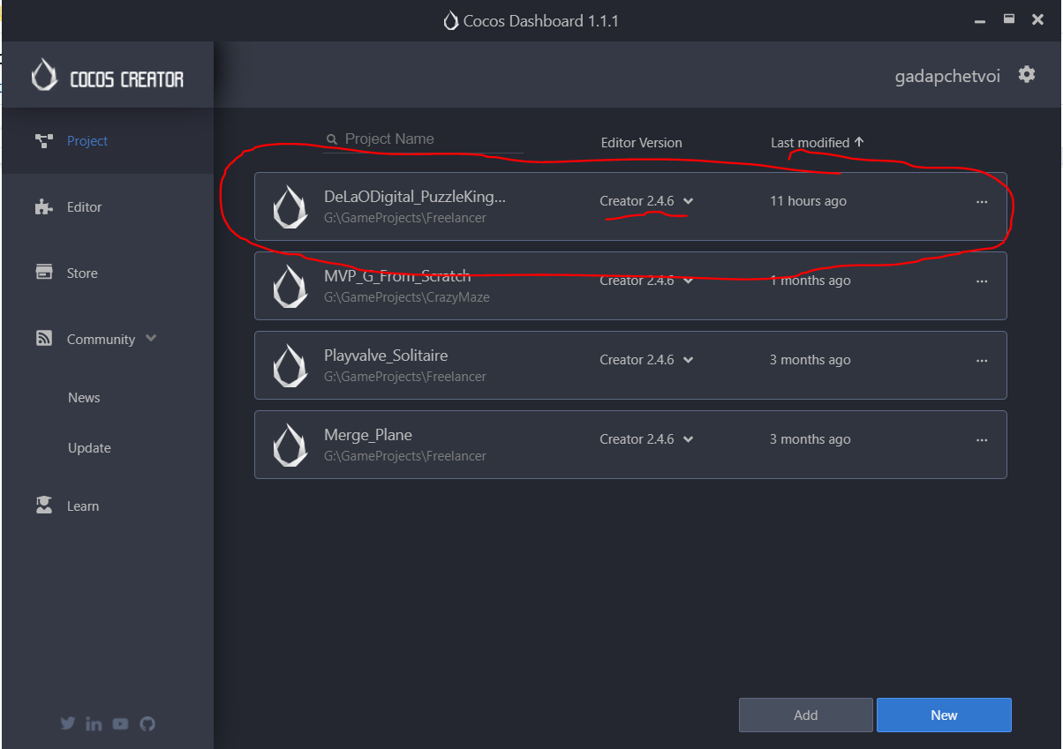

When the project is fully opened, wait 10 seconds for Cocos to realize new resources.  
 Then click “Project” > “Build”

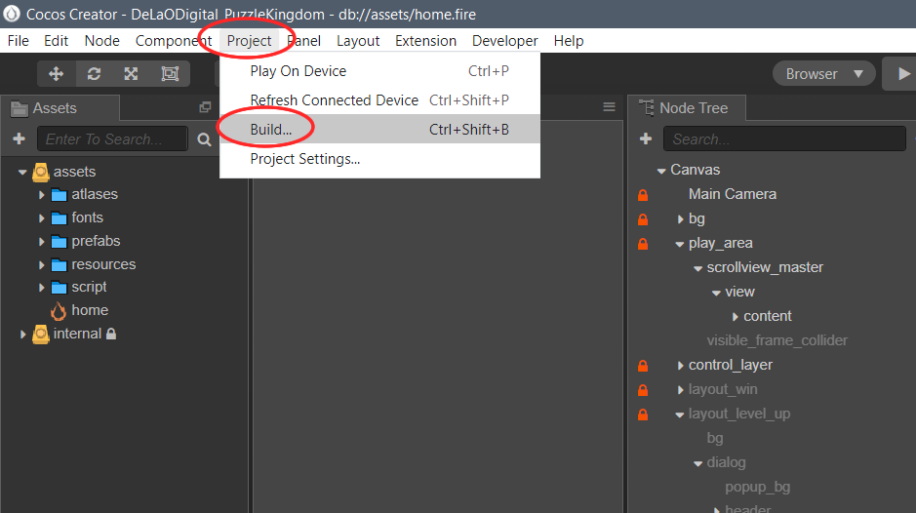

A popup shown to help build the project.  
 Click to select the settings like below picture, then click “Build”

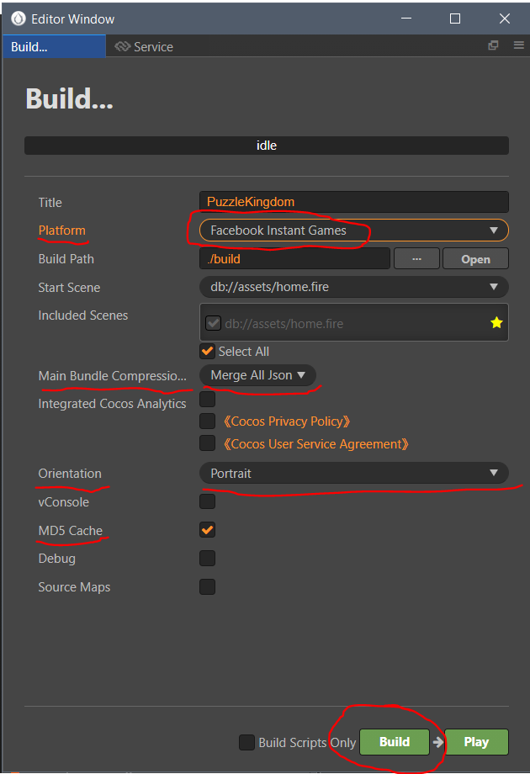

When the build process finishes, a folder is popped up.   
 The file we need is highlighted as a zip file (file to upload to FB Host)

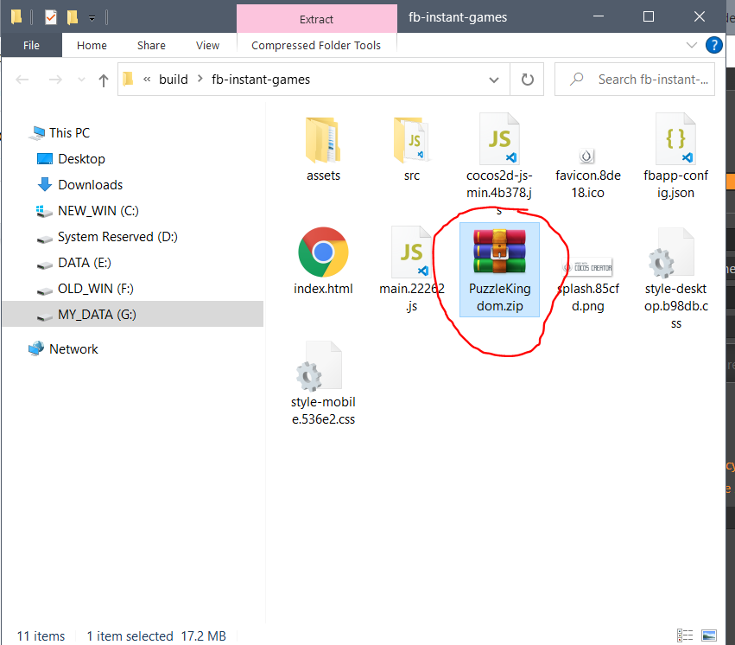

1. Upload to FB Host
   1. Visit hosting page

<https://developers.facebook.com/apps/546140006799320/instant-games/hosting/?business_id=118344820320143>

* 1. Click Upload

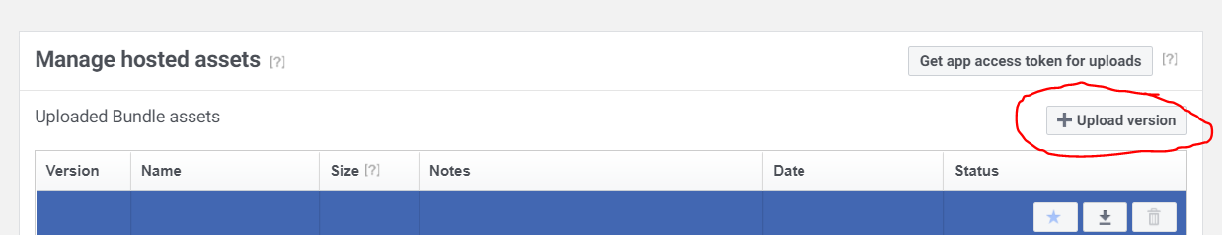

* 1. Select the zip file in the last step & type in the “About…” then click “Upload”  
       
     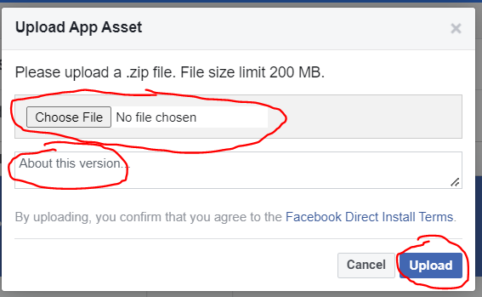
  2. Wait a few seconds for the popup above to auto hide. After that, **refresh the webpage** to see the new uploaded file to show in list  
       
     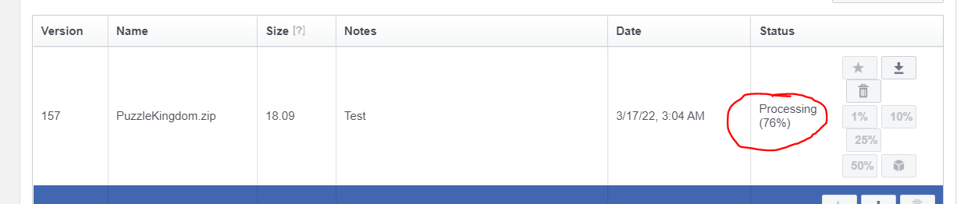
  3. When processing goes 100%, the buttons should become available  
       
     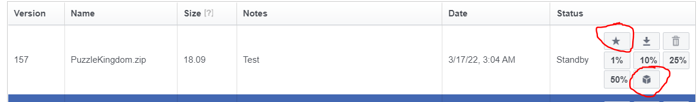
  4. Click the **button** **star** to set the new uploaded file to be Production - available to all users
  5. Click the **button** **3d-box** to set the new uploaded file to be Test version - available only to developers & admins
  6. Click the **button** **1%, 10%. 25%, 50%** to set the new uploaded file to be 1 of 2 A/B Testing versions (the other version is the current Production version - uploaded before). The **percentage number** is the ratio of the chance that a new user enter the new uploaded version
  7. Enter password if being asked
  8. Done